8 Mile Cruisers Cup Regatta
The Cruisers Cup Regatta shall be limited to cruising sailboats equipped with interior, minimum 1 anchor, Dacron or Nylon sails only and an operational motor. Finish order will be determined using the PHRF handicap system as well as a points system to be announced at the beginning of each race.
Start time will be at 10am. The start/finish will be on the south side of the lake outside of Honeymoon Cove. Cruisers will sail first around Horse Island, then around Balance Rock, then around the unnamed Island near the damn (33*51.07 N, 112*16.57 W), then back to the start/finish line. The course is roughly 8 miles at its quickest route. Round all marks to port.
Note:
All boats must check in by sailing past the GoSailAZ chase boat located near the start/finish line. You must hail with skippers name, boat name, and boat make and size.
Race information will be broadcast on VHF channel 13.
After the finish: We meet at the Waterfront Grill for trophies, prizes, games, food and drinks
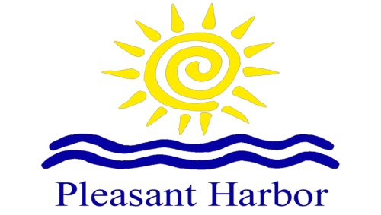
Additional Information:
Fleet Captain: Clint Sutter 602-882-4398
Go to www.GoSailAZ.com for scheduled races and more information
Race information sheets can be picked up at the GoSailAZ office located at the end of the ramp on Pleasant Harbor Marina.

Starting Sequence:
5 Minutes- short blast on horn and flag goes up.
4 minutes- short blast on the horn (racing rules go into effect)
1 minute- prolonged blast on the horn and flag comes down
0- START- short blast on the horn
