8 Mile Cruisers Cup Challenge
The 8 Mile Cruisers Cup Challenge is a Cruising Boat competition held monthly at Pleasant Harbor Marina on Saturdays and Sundays. All boats will be Cruiser Class and include: interior, anchor, Nylon or Dacron sails, and an inboard or outboard motor. A handicap system will be used to determine finish order, (PHRF). (There will also be a separate points system to be announced at the beginning of each race to make things interesting :)
Skippers meeting on the dock at 9am. Start time is 10am. The start/finish line will be on the south side of the lake outside of Honeymoon cove. The course will go around Horse Island, then around Balance Rock, then around the island located near the dam (33*51.0 N, 112*16.6 W), then back to the start finish line. The course is roughly 8 miles. You must go keep all islands to port when you round them.
Note: All boats must check in by sailing up to the GoSailAZ chase boat located near the start/finish line. Please hail the skippers name, boat name, boat size, and sail #.
In conjunction with the Arizona Yacht Club and Pleasant Harbor Marina, we will be hosting Beginners Race Clinics and Introduction to Racing classes.
Go to www.GoSailAZ.com for scheduled clinics and more information.

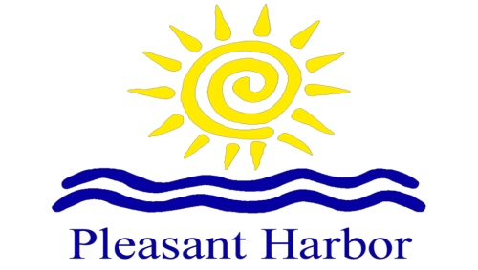

Additional Information
Fleet Captain: Clint Sutter 602-882-4398
Cruisers Cup information sheets can be picked up at the GoSailAZ office located at the end of the ramp at Pleasant Harbor Marina.
Event information will be broadcast on VHF channel 13.

Starting Sequence:
5 Minutes- short blast on horn and flag goes up.
4 minutes- short blast on the horn (racing rules go into effect)
1 minute- prolonged blast on the horn and flag comes down
0- START- short blast on the horn
